Did They Ever Return?: The Development of a Committee Property Rights “Norm”
for State Legislators During the Twentieth Century

Keith E. Hamm Ronald D. Hedlund Greg Vonnahme
Rice University Northeastern University Rice University

Prepared for presentation at the eighth annual State Politics and Policy Conference at Temple University in Philadelphia, May 30-31, 2008.

This research has been supported, in part, by two National Science Foundation grants (SES-8411353 and SBR-9511518), by Rice University, and by Northeastern University. We also wish to acknowledge the contributions made by the many students who assisted us in collecting and entering the data used in this project.

Did They Ever Return?: The Development of a Committee Property Rights Norm for
State Legislators During the Twentieth Century

Introduction
The study of committee property rights (the power that accrues to a committee and hence to its members as a result of its exclusive jurisdiction over policy decisions within its areas of policy control) has fostered the analysis of legislative committee selection and establishment (e.g., Jenkins, 1998). Until recently, most of this research focused on congress and especially the House. The purpose of this paper is to determine if a variety of organizational/institutional variables currently thought to be important in the design of legislative bodies, has a significant impact on the reappointment of members to state legislative committees throughout the 20th century, a key indicator of the importance of property rights at the individual level. We focus on the extent to which institutional structures (i.e., degree of professionalization), legislative careerism, committee powers, political party competition and control of the appointment process affect the rate of member committee reappointment in state legislatures. Our data base includes 441,840 committee positions (legislators having a seat on a standing committee for a two year session) on 40,936 committees in the houses during 20 legislative sessions (i.e., the last two legislative sessions in each decade of the 20th century) in the upper and lower houses of 35 state legislatures. This analysis will permit extensive consideration regarding the existence of property rights for members of U.S. legislative bodies in general, the extent of property rights across an extraordinary period (the entire 20th Century), as well as the relationships of organizational-institutional factors with property rights. Before we begin this analysis, however, we provide an overview of the argument for comparative state legislative research as a means to enrich the study of legislative bodies.
The Advantages of Comparative State Legislative Studies
The field of legislative studies finds itself, in our opinion, at a crossroads. The general consensus is that “the scholarly world of legislative studies is, overwhelmingly, a world that studies the U.S. Congress” (Gamm and Huber, 2002: 313). This statement is particularly true for the scholarly study of the role of committees in U.S. legislatures. Whether it is Fenno’s (1973) authoritative analysis focusing on the variation in role of committees as a function of members’ goals and the political environment in which they act, or the more stylized models that focus on the distributive (Shepsle, 1978; Weingast and Marshal 1988), partisan (Cox and Mc Cubbins, 1993) or informational (Krehbiel 1991; Gilligan & Krehbiel 1990) perspectives of legislative organization, the object of study is the U.S. Congress. The positive and negative implications of this preoccupation are aptly described by Gamm and Huber:
The most obvious implication, we believe, is the extent to which congressional scholarship has served as a model of positivist, rigorous, scientific research for the more general study of legislatures . . . But the primacy of congressional research has also exacted costs, primarily biases that are created in the type of questions scholars pose and in the types of answers they provide to these questions (314).
In their recent book, Squire and Hamm make a forceful case for American legislative studies to adopt a more comparative, across legislature perspective:
Studying a single institution in isolation, whether it is the U.S. House or the California Assembly, can provide many insights into many aspects of legislative behavior. But only by examining those insights in a broader context, only by testing them comparatively, can a more complete understanding be approached (2005: 152).
They suggest that “truly generalizable theories should be portable from one American legislature to another. If theories prove not to be portable, at least their limitations will be illuminated in the effort” (2005, 3).
The utility of the comparative approach can be seen in the debate over the composition of legislative committees relative to their parent body which is one of the dominant themes in contemporary legislative research. Composition in terms of the degree to which the legislative committee “typifies” or is an “outlier” from the nature of the parent chamber is presumed to have impact on how committees work as well as on their policy outputs. Initial research on this phenomenon was conducted extensively at the congressional level. To test the generalizable aspects of the distributive, informational or partisan theories as they can be applied to the study of outlier committees, several recent published articles have utilized data from state legislatures (Overby and Kazee, 2000; Aldrich and Battista, 2002; Overby, Kazee, and Prince, 2004; Prince and Overby, 2005; and Battista, 2004, 2006a, 2006b). The general conclusion is that most committees are not composed of outliers.
The second example extends some of the Cox and McCubbins (1993 and 2005) argument regarding the strategies parties use in seeking to maximize their control over the legislative process. Partisan stacking of committees is viewed in the theoretical literature on Congress as one way to achieve a super proportion of controlling offices in a legislature (Cox and McCubbins, 2005; Porter, et al 2005). State legislative studies which have concentrated on party ratios on committees (e.g., Hedlund and Hamm ,1996; Hedlund et al, 2007) have not reinforced the presumed predisposition of the majority party toward the stacking of legislative committee membership. For example, research on the partisan nature of state legislative committees during the 20th Century found that the dominant committee party composition pattern was one that closely reflected the pattern found in the parent body with relatively modest over- and under-proportional majority party representation regardless of institutional constraints (Hedlund and Hamm,1996). Extending the analysis into the 21st century, Hedlund et al (2007) note that the proportions of majority party members on committees exceeds that for majority party members in the chamber in well over half of all the standing committees in 2003-4 and 2005-6 (2007, 18). At the same time “. . .we find that the overwhelming percentage of committees, over 84%, can be considered as ‘approximations’ of no difference (or no significant variation) in chamber-committee proportions. It thus appears as if the vast majority of committees have a proportion of majority party members which approximates that of the chamber as defined by this procedure” (2007: 19). Furthermore, both of these research reports note instances when the majority party “under-represents” itself on committees. These studies point to the advantages inherent in a comparative approach that includes the study of a variety of U.S. legislative bodies rather than a focus on only a single institution.
The comparative approach thus permits researchers to identify the extent to which the attribute or behavior in question is distributed uniformly across institutions. The studies of committee composition and committee party ratios document the degree of inter-institutional variation. For example, Battista (2004), notes that not only are outliers rare, but “[I]n fact, these unrepresentative committees are clustered in just a few chambers, with the other chambers being significantly more representative than by chance” (2004: 169). In a recent study of the degree of committee stacking in the state legislatures during the 2003-2006 period, Hedlund et al note that the existence of committee over-proportional majority party representation (MPR) on committees varies significantly across states and chambers. They note that “we find committees with over-proportional MPR in the lower chambers, its frequency ranges from 1% to 80% of all committees. In the upper chambers we again see a far less dramatic difference, with the percentages ranging from 2% to 46%” (2007, 19). In other words, institutional differences are tremendously important since the variation is greater across institutions than within institutions.
Given the extra explanatory leverage provided by comparative cross-sectional and longitudinal analysis of state legislatures, we now turn our attention to a key variable in the committee composition literature, namely the reappointment of members to committees. We first contrast the establishment of committee property rights in Congress with those in the state legislatures, before moving on to provide an explanation for their uneven development in the states.
The Puzzle: Variation in State Legislative Committee Property Rights
The reappointment of members to committees across legislative sessions is a key indicator of committee property rights at the individual level because it indicates the degree to which committee members see continued service on that committee, with its policy jurisdictions, as an important element in their legislative service. Committee members moving across committees suggests that service on the committee from which they moved was not sufficiently effectual to their goals and priorities that they should remain on that committee in order to pursue their policy objectives and/or the needs of their constituents. The decision to continue serving on a committee, when given the opportunity to change (at the start of a new legislative session), indicates a high level of satisfaction by the member that continuing involvement in that same policy area jurisdiction affords the member. Continuing that service provides opportunities to enhance their power and standing through additional efforts in that policy area. Ergo, continued service on a committee across legislative sessions is an indicator for members exercising their committee property rights.
The initial research question is whether the rate of reappointment of legislators to committees varies across time and across legislatures. To those who study the U.S. Congress, this question is relatively irrelevant and uninteresting since “[Except] under the most unusual circumstances (substantial changes in party ratios for example), both parties in both chambers allow members to retain their assignments as long as they desire—the so-called property rights norm.” (Deering and Smith, 1997: 101). In terms of explaining the rise of committee property rights, Katz and Sala (1996) develop a major theoretical statement. Linking the introduction of the Australian ballot to the development of committee property rights in the US House of Representatives, they argued that the Australian ballot gave members of the House an incentive to pursue personal constituency votes.
The ballot changes raised the interest of members of Congress in institutional arrangements that would help them build personal reputations. Stable committee assignments give members the leeway and confidence they need to become policy experts within their committee jurisdictions. Policy experts are better equipped to claim credit and are more noteworthy position takers on policies within their committee’s jurisdiction than are randomly selected members of Congress. Hence, a ‘norm’ of reappointing incumbents to their same committees would be consistent with a widespread desire for building a personal reputation. (1996: 23).

Does this argument apply to the state legislatures? One strategy would be to simply assume that the relationship found at the congressional level holds for other U.S. legislatures. Rather than make this assumption, Squire, Hamm, Hedlund and Moncrief (2004) tested Katz and Sala’s theory at the state legislative level. After showing that state legislatures at the turn of the 20th century were important institutions in American political life, and that it is fair to compare the U.S. House with state legislatures as legislative organizations during this time period, they proceed to find little evidence that committee property rights appeared in state legislatures at the same time as they took root in the U.S. House of Representatives, even though both institutions were exposed to the same electoral reform simultaneously. Their main finding is that the change in the electoral system was influential only in conjunction with a substantial level of membership stability in the institution. Thus, Squire et al contend that the analysis is consistent with Price’s observation that, “[F]or the House there could be no question of modern-type “seniority” until membership instability was reduced to a level such that there was substantial continuity of committee service. Such de facto stability tends to generate demands for de jure seniority.” (1975, emphasis added) .
Given the prevalence of this committee property right norm for such a long period of time, Deering and Smith observe that scholarly work on committee assignments “simply assumes that members will continue their memberships on existing committees.” (1997: note #79, p122). The research question we ask is whether this norm is generalizable to other U.S. legislatures.
We begin our analysis by focusing on the development of state legislative committee systems in the 20th century. In previous work, we have traced the multi-dimensional nature of committee specialization in the state legislatures and shown how various components have changed over time (Hedlund and Hamm, 1994; Hamm and Hedlund, 2004; Hamm and Hedlund, 2006). Specifically, state legislatures, despite increases in state’s populations and workload, have streamlined operations and rely on fewer permanent committees and a fewer number of assignments per member at the end of the 20th century.
The creation of committee property rights requires a committee system that is somewhat stable from session to session. Were state committee systems stable throughout the 20th century? First, we examine this question by looking at the percentage of committees with a consistent (i.e., the same) name from one session to the next in the same decade. Using this definition, relative stability (similar names for more than 90 percent of the committees) existed during the first six decades, only to be followed by greater change in the 1960s and 1970s and then in the 1980s a return to having more than 90 percent of the committees having a consistent name from session to session (see Hamm and Hedlund, 2006). State legislatures thus exhibit considerable jurisdictional consistency except during a period of extraordinary legislative reform among these institutions.
A second component of stability relates to the number of similar committee positions across the legislative sessions. In order to determine the extent of stability in the number of positions, we started with those committees that existed in two consecutive sessions and calculated the percentage of positions that carried over from one legislative session to the next. If no changes were made to the committee system, the figure would be 100%. Reduction in the number of positions would result in a figure lower than 100% and expansion of the committees would show a figure greater than 100%. Our analysis indicates that committee stability was the norm in the 1909-1959 period in the 70 chambers studied with a mean of 95.17% and a S.D. of 14.4. On the other hand, the distribution for the 1969-1999 period shows significantly greater instability (mean 88.56%, S.D= 18.56) with most committee systems exhibiting less than 100% of the positions in the second session as existed in the first. Thus, we have established that at least a minimal condition (stability of committees by jurisdiction) existed for the establishment of committee specialization via reappointment to the same committee.
In addition, sufficient evidence exists that members are reappointed to the same committee, but substantial variation exists across time and across legislatures. We arrive at this conclusion by focusing on two indicators. The first step involves focusing only on those committees which exist for two consecutive legislative sessions. Then we determine the number of members who served on the same committee during both legislative sessions. The first measure, the total carryover rate, is simply the percentage of members reappointed to the same committee divided by the total number of positions existing on the reoccurring committee. The second measure is the committee member retention rate which taps the committee property rights norm. It is the percentage of legislators re-elected who are re-appointed to the reoccurring committee.
As shown in Figure 1, the total committee carryover rate starts at around 27 percent in the first decade of the 20th century in the upper houses, increases during the next two decades, drops somewhat in the 1930s, followed by a monotonically increasing pattern through the 1990s, finishing off at roughly 60 percent in the 1999 session. The pattern for the lower houses is similar, but with a value of only 11 percent in the 1909 session and roughly 55 percent in 1999. The focus on means, however, masks substantial variation within any one time period. For example, in the 1957-1959 timeframe, the range of carryover scores varied from 2 to 97 percent in the senates and from 13 to 72 percent in the houses. Similar results can be found for each decade in the 20th century. Change, however, also exists across legislatures across time. The complexity and differential nature of the process is shown in Figures 2 and 3 for selected upper and lower houses, respectively. Rather than being a linear increase, we see that total committee carryover moves in fits and starts—a very erratic pattern that differs across legislative institutions.
The patterns for the committee member retention variable are similar, although the initial values in the 1909 decade are much higher. (See Figure 4.) There has been substantial increase over time, and at about the same rate in both chambers. Since the 1940s, the overall mean value for the lower houses has been greater than 50 percent, meaning that committees retain a majority of members who have been reelected. This is true for senates as far back as 1907/09. In the late 1990s, the mean committee reappointment rate is greater than two-thirds in 26 of 35 state senates and in 22 of 35 state houses. The clear implication is that a significant number of the re-elected members are re-appointed to the same committees on which they sat in the earlier legislative session. The puzzle, however, is that this trend is not continuously linear across time, nor is it consistent from chamber to chamber. We demonstrate this variability in Figures 5 and 6.
Taken together, while we believe that these trends indicate an enormous enhancement in the specialization of legislators via the committee system, at the same time, these trends pose the intriguing question as to what accounts for both the cross-sectional and longitudinal variation. The research question is whether key variables in the institutional design literature have an appreciable effect on the reappointment of members to committees.
Explaining Variation in Committee Reappointment: Institutional and Individual Factors

Professionalization
A consistent finding in research has concluded that state legislatures varied across the 20th century and across states at any time point in both their institutional characteristics and in the characteristics of their members. A substantial amount of research has been devoted to conceptualizing and measuring theses characteristics. One key to understanding these differences is tied to the concept of professionalization. At the institutional level, Nelson Polsby described professionalization as a means for transforming legislative bodies so as to enhance their capability and ultimately their independent power (1975). H. Douglas Price, writing in 1975, associated institutional professionalization with such organizational structure and process factors as a reduced influence disparity among members, enhanced capability vis-à-vis the executive, greater autonomy from outside influence, and strengthened legislative committees. (1975). By far, the most cited and utilized definition was developed by Squire. He noted that a professionalized legislature has “ . . . higher member remuneration levels, staff support and facilities, and service time demands. Legislatures deemed professional are those which meet in unlimited sessions, pay their members well and provide superior staff resources and facilities. Essentially, such a body offers potential and current members incentives sufficient to consider service as a career.” (1992b: 1028).
Professionalization has also been conceptualized as involving individual goals and characteristics (Price, 1975; Rosenthal, 1996). Rosenthal extended the two-level analysis and noted that legislators themselves can become more “professional” in how they go about their activity within the organization—amount of time spent on legislative tasks, self-identity with a legislative/public servant occupation, reliance on non-legislative employment, and future political ambitions—somewhat independent on what is transpiring at the chamber level. In other words, the operative question is “to what extent do members view legislative service as a career or full-time job rather than as a part-time, fleeting avocation? (Battissa, 2006b: 8). The point is that while institutional and individual professionalization are obviously related, not all legislators in a professionalized legislature describe themselves in professional terms and some legislators in less professionalized bodies describe themselves in professional terms (Rosenthal, 1996: 174-176). A recent study confirms that while the amount of time members devoted to the job was positively related to legislator compensation, a measure of institutional professionalism, no effect could be found for days in session, a key measure of professionalism. (Kurtz et al, 2006: 330)
Squire’s insightful analysis of the relationship between member career opportunities and the internal organization of legislatures highlights the possible disjuncture between the institutional and individual level variables (1988b). While he addresses several aspects of the internal organization of legislatures, the relevant portion of his analysis is the comparison of the stability of committee assignments in two highly institutional, professional legislatures (i.e., California and New York) and one modestly professional organization (i.e., Connecticut). The crux of the argument is that “The New York Assembly, given its members’ career orientation, should be the most stable. California and Connecticut should have greater instability because of higher turnover and the short-term outlook of their membership” (1988b: 738). In other words, the general expectation is that the establishment of committee property rights should be greater in those institutions in which the members intend long service on a committee. In other types of legislatures, we would expect a different institutional pattern
Aside from the previously mentioned Squire et al article (2004), two other studies have highlighted the importance of membership stability on committee continuity. Basehart (1980) examined data on eight lower houses and seven upper chambers covering 1963-1977. He concluded that membership stability was positively related with three of the four indicators of committee continuity and experience. In an earlier paper we (i.e., Hedlund and Hamm, 1994) also highlighted the importance of membership stability as a factor in increasing retention rates on committees. These findings are in keeping with the more general explanation for the creation of this property rights norm in the early part of the 20th century in the U.S. Congress.

The vesting of a property right in committee assignments arose in the early twentieth century, due to the demand among rank-and-file members for a more predictable career path within Congress. Keep in mind that this is a time when legislative careers were lengthening rapidly, leading rank-and file members of Congress to use their congressional service to further political goals. (Stewart 2001: 293).

We, thus, are left with two very different expectations about the impact of professionalization on committee property rights. Adopting the career opportunities perspective, legislators who seek long-term service in the same legislature, rather than seeking higher office or retiring from politics, would place a higher value on developing specialization (and property rights) via reappointment to the same set of committees in order to achieve one or more of the generally agreed upon set of individual goals --- re-election, policy influence or power in the chamber (Fenno, 1973). The institutional perspective, however, devoid of any career component, does not yield any clear hypothesis.
Committee Powers and Legislative Rules
The focus on committee retention rates is related to the assumption that committees play an important role in the legislative process. While this assumption has long been true in the U.S. House, it has not always been the case in some state legislative chambers. Although committees in every legislature are involved in lawmaking, we know their importance varies, both over time within a particular legislature, and across legislatures “so as to call into question any single statement about the foundation of committee power” (Squire and Hamm 2005: 126). Take for example Shepsle and Weingast’s (1987) highly influential argument regarding the institutional foundations of committee power. Their emphasis on the importance of the ex-post veto available at the conference committee stage rests upon several assumptions about the existence, composition and operation of conference committees. Squire and Hamm point out that conference committees are not necessarily a regular feature of all American legislatures. Even if they exist, their membership does not necessarily come from the substantive committees that had control over the legislation in each chamber. The ability of the committees to alter legislation ranges from very limited to extremely open while decisional rules vary from the congressional model. In other words, this important institutional aspect of committee power should be conceived as extremely variable across American legislatures, implying that a more general theory must be provided (2005: 113-115).
How do we develop a metric that permits us to capture these differences in committee powers across legislatures and across the course of the 20th century? Our initial suggestion is to focus on the range of committee powers found in the legislative rules of each chamber or perhaps in a set of joint rules. While the various models of committees have been developed (i.e., distributive, informational, etc.), at this stage we are not testing or identifying with any particular persuasion. Instead, we are trying to ascertain the types of committee powers that might impact the preference for committee property rights. We start with a traditional discussion of the legislative process using the U.S. Congress as a baseline, and point out how the variation in the rules will affect members’ need to establish committee property rights, all else being equal.
Gatekeeping powers are often thought to be a necessary foundation of committee power. If committees exercise little or no gatekeeping power, then we would assume there would be little incentive to continue membership on any particular committee. We start with a focus on three key factors: (1) the requirement that all legislation be referred to a committee; (2) committees have clearly defined jurisdiction over the designated policy area; and (3) the right of these committees to refuse to report legislation to the floor. Variation exists across state legislatures in the extent to which committees have the ability to control what reaches the floor. While the referral requirement exists in most states, the negative ‘gatekeeping” power varies substantially across the state legislatures because of differences regarding clear committee jurisdiction and the inability of committees to limit the specific legislation that reaches the floor.
The jurisdictional prerogatives of congressional committees are fairly well understood. Thus, as Stewart (2001, 277) notes, “The rules of both chambers now delineate in fine detail which matters belong to which committees.” Research has shown that committee jurisdictions are not listed in the rules in roughly two-thirds of the state legislative chambers studied in the 1999 legislative session (Martorano, Hamm and Hedlund 2000). We thus must incorporate the committee jurisdiction concept as a variable into our analysis. Our contention is that without the guarantee of a well-defined jurisdiction, members have less incentive to return to a given committee in order to achieve their policy objectives. The other aspect of this negative committee power involves whether all legislation must be reported back to the chamber and the extent to which the legislature can withdraw bills that do not have support in the committee. A committee is better able to perform this gatekeeping function if: (1) they do not have to consider all legislation referred to it; (2) there is no requirement that committees report all bills to the floor; (3) they do not have to meet deadlines for committee action; (4) the floor cannot demand a committee report, and (5) the floor has difficulty withdrawing legislation from a committee’s consideration. In summary, the main argument is that the greater the gatekeeping powers a chamber’s committees have, the greater the probability that members will want to establish committee property rights, all else being equal.

Political Party
Given the work of Cox and McCubbins on the importance of the majority party in the appointment process, it would be inappropriate not to include at least one hypothesis that takes into account the role of the party. Political parties organize every American legislature, save for Nebraska (and, in recent history, Minnesota from 1914 to 1973). In some cases, however, all members belonged to the same party (e.g., Michigan 1909 House and Senate, 1929 Oregon House, as well as several southern legislatures for a substantial part of the 20th century). Research by Francis indicates that when it comes to exercising power, a crucial variable is size of the majority party. Political party caucuses are more important in those chambers in which parties are more evenly matched and smaller in terms of total membership, whereas, when the size of the majority party increases, committees take on more responsibility (1989: 45-46). Using this argument, we would suggest that higher levels of reappointment, all else being equal, would be greater in those chambers in which the majority party has a large majority.
We also envision that political parties will be important in the assignment process when there is a change in party control. The case of the Republican takeover of the Florida House in 1998—the first partisan change in over 120 years-- is perhaps the most extreme case of a committee makeover. The new Republican majority “… abolish[ed] subcommittees; increase[d] the number, but [shrank] the size, of standing committees; eliminate[d] the calendar committee and change[d] the calendar system . . . , establish[ed] strong germanity rules; and permit[ed] closed bills under certain circumstances” (cited in Squire and Hamm, 2005, 100 from Jewett and Handberg, 1999, 27). We do not expect that such significant changes will occur with each change of party control, but we do believe that a change in party control will be negatively associated with committee retention rates.

Legislative Rules- Appointment Process
One variable that must be included in the determination of reappointment of members to committees involves who actually makes the decisions on committee appointments. We work from the framework that the more this responsibility is shared among the members of the legislature, either through a committee on committees or via an entire chamber decision, the greater the probability that members will have their wish for reappointment granted than if the decision is made by a single leader.
In conducting the analysis of committee property rights, we need to include an explicitly stated seniority rule, which occurs rarely at the state level, but should have a profound effect on reappointment rates. Krehbiel, in his discussion about the informational expectations about seniority develops the case that “a legislature would not commit to a seniority rule but will follow a seniority practice.” (1991: 143). Our reading of the legislative rules suggests that while the establishment of this rule is infrequent, there are instances where it does exist. For example, the rules of the Georgia House (Rule 6) state that, except for the Committee on Rules and the Committee on Interstate Cooperation, “a member shall remain on the committee to which he is appointed so long as he is member of the House,” while in the Georgia Senate (Rule 185g) the same rule applies without exception. (quoted in Squire and Hamm, 2005: 112). In chambers with this type of rule, we would expect that the reappointment rates would be significantly higher than in other legislatures, all else being equal. Of course, if substantial shake-up occurs on the prestigious committees, there might be sufficient reason for members to forego their earlier assignments and seek new positions.

Supply of Committee Positions.
In order for legislators to be reappointed to committees, there must be some stability in the committee system from one legislative session to the next. Obviously, if the committee system is re-structured every two years, the amount of committee carryover will be minimal. On the other hand, if the number of positions expands across sessions, the chance for reappointment should increase since other members’ requests can be accommodated without jeopardizing the possibilities of those who want to be reappointed.

Institutional Structure
State legislatures also vary along a variety of other organizational characteristics. The most pertinent factors for this analysis are size of the legislature, upper versus lower chamber, joint committee use and length of elected term.
The structure of a committee system is often seen as a function of the size of the parliamentary/legislative chamber. Using concepts from organization theory, Froman hypothesized that " . . . the larger the size of the organization, the greater the number of subgroups in it" (Froman, 1968:524). Part of Froman's evidence came from his comparison of the two houses of the U.S. Congress. Shaw, on the other hand, can find no relationship in his summary of committees in eight national legislatures. (1979: 367). Blondel weighs in on this point by stating that: "If we do concentrate on these legislative committees, however, we find that marked discrepancies separate legislatures across the world from the point of view of their apparent activities even if the size of the chamber is taken into account" (Blondel, 1973: 69). Scholars who have studied the emergence and development of U.S. state legislative committees give some support to the size hypothesis (Jameson, 1894, Morris, 1982). Winslow, in his classic 1931 study, observed that there was a relationship between size of the legislative body and number of committees and the average size of the committee (1931: 38-39). Francis and Riddlesperger (1982) have provided the greatest evidence for this hypothesis in their study of committee system in the 99 U. S. state legislative chambers during the early 1980s.
In terms of committee reappointments, Basehart reports some evidence that committee membership stability in state legislatures increases with the size of the legislative chamber. In an earlier study including 28 chambers, Hedlund and Hamm (1994) found that the size of the chamber was positively related to number of committees, number of committee positions, and average committee size. Size was also negatively related to committee continuity in the 1907-1949 period and unrelated in later decades.
Reappointment rates may also be affected by the use of joint committees. Members seeking a career in legislatures which use a preponderance of joint committees are hypothesized to have less incentive to seek reappointment to the committees because they have less control over the legislative outcome (i.e., less potent property rights) than in those systems which use only chamber committees.
A third organizational difference relates to the length of term for the elected state legislator. Here we are most concerned with those chambers in which all members are elected once every four years. Since our analysis consists of two-year intervals, the expectation is that legislators will treat the legislative term as simply one four-year term, and make little or no changes during the latter half of the second term. For example, over 95 percent of the Kansas senators were reappointed to the same committees four times in the years under investigation—1919, 1939, 1959 and 1979. These results are some of the highest obtained for the 600 plus legislative sessions studied.
Research on the U.S. Congress highlights at times the differences between the house and senate. Since it is not possible in this research undertaking to include all of the various factors that possibly differentiate senates from houses, we simply employ a variable that accounts for the fact that the chamber is either the house or the senate.

Sample Selection
Due to the longitudinal and multi-state nature of this research, the unit of analysis and data collection was very important. Several rules guided the selection of the unit of analysis and the scope of the study. First, since many differences exist between the two chambers of any bicameral legislature, especially in their organizational traits, each legislative chamber (Senate and House/Assembly), must be treated as a separate unit of analysis. Second, since popularly elected legislative bodies at the state level usually undergo changes after each annual or biennial election and since legislative standing committees (the sub-units having substantial powers regarding policy decisions) are usually formed to last until the next election, each two-year session (or one-year session for three early state/sessions) of a legislative chamber is considered a distinct data collection unit. When the entire legislative body is elected every four years, we treat the period as having two distinct two-year data points. Third, since it is very difficult to analyze all legislative sessions during the twentieth century, we examine legislative committee specialization during the last two sessions of each decade (i.e., 1907/1908 & 1909/1910, 1917/1918 & 1919/1920, 1927/1928 & 1929/1930, 1937/1938 & 1939/1940, 1947/1948 & 1949/1950, 1957/1958 & 1959/1960, 1967/1968 & 1969/1970, 1977/1978 & 1979/1980, 1987/1988 & 1989/1990 and 1997/1998 & 1999/2000).
In our larger study we examine a total of 441,840 committee positions (legislators having a seat on a standing committee for a two year session) on 40,936 committees in the house and senate in 35 states-- Arizona, California, Colorado, Connecticut, Delaware, Georgia, Iowa, Idaho, Illinois, Indiana, Kansas, Maine, Maryland, Massachusetts Michigan, Minnesota, Missouri, Montana, Nevada, New Hampshire, North Carolina, Oklahoma, Oregon, Pennsylvania, Rhode Island, South Carolina, South Dakota, Tennessee, Utah, Vermont, Virginia, Washington, West Virginia, Wisconsin and Wyoming. For this study, we focus on those committees that exist in two consecutive sessions under study. A multi-level analysis is conducted with committees nested within chambers which are nested within states.

Operational Definitions
Professionalism Regarding measurement, Squire accepted the widely acknowledged definition and formulation of a transformed U.S. Congress (Polsby, 1968), as the essence of an institutionalized/professionalized legislature and proceeded to formulate a new measurement approach. Squire developed a measure of professionalization that used Congress as the “baseline” against which state legislatures would be compared. Considerable consensus has come to exist regarding how professionalization in U.S. state legislatures is defined and measured. We utilized data from Squire’s most recent paper (2006b). He measured legislative professionalization at nine points in time—1910, 1935, 1945, 1954, 1960, 1979, 1986, 1996 and 2003. Since professionalization level is hypothesized to change slowly, this range of measurements is sufficient; hence we used the data that was closest in time for each decade of our analysis.
While we would prefer to have a measure of legislative careers for the level of professionalization at the individual level, we have settled on membership stability which is defined as the percentage of legislators serving who had served in the previous legislative session. This indicator is one of the few measures of legislator professionalism readily available throughout the 20th century.
Committee Powers and Legislative Rules Hamm, Hedlund and Martorano (2006), utilized a procedure focusing on legislative rules, developed by Mattson and Strøm (1995) in their study of committee powers, structures, and procedures in 18 European parliaments. Our measures of formal committee power were developed based on the reading of three major sources of state legislative procedure: constitutions, statutes, and formal rules. Each of these sources can impose formal constraints on a state’s legislative committee system. Of course, committee power can also be influenced by informal norms of behavior, but we focus on formal state legislative powers and procedures since very little comparable information exists about the informal functioning of committees, especially in the early 20th century.
Using factor analysis, we uncovered six dimensions of committee power. In this paper we concentrate on the committee Independence dimension, relabeled as the Gatekeeping Component. Five indicators tap this dimension of committee autonomy:
- No requirement that all referred legislation be considered by the referral committee;
- No existence of deadlines for committee action;
- No requirement that committees report all bills to the floor;
- The inability of the floor to demand a committee report; and
- The inability of the floor to withdraw legislation from a committee’s consideration.
To simplify matters, we summed across the various indicators and coded the Gatekeeping measure as 1, 0 or -1.
We also include a variable that taps the degree to which committee jurisdictions are listed in the rules. This variable is measured from 0 (when there is no mention at all of any committee jurisdictions) to 1 (which is used where the jurisdiction of every committee is clearly delineated).

Political Party Variables Two variables are used to gauge the impact of the political party on the appointment process. The first simply reflects the relative size of the majority party in the chamber. The second variable reflects whether there was a change in party control from one session to the next.
Legislative Rules- Appointment Process No single authoritative source exists that documents who had the power to appoint members to committees in state legislatures throughout the 20th century. For the most recent period, Clucas (2001), in measuring speakership power in the 1990s, documents the wide range in power that speakers had over the ability to appoint other leaders, committee chairs, and committee members. According to a 1998 study by the American Society of Legislative Clerks and Secretaries and National Conference of State Legislatures (1998, Table 96-4.8), the minority leader appointed minority party members in 18 chambers while making recommendations in another 22 chambers. We decided to examine the rules and legislative journals to make a decision as to who had this power in the 600+ legislative sessions that we studied. While not capturing all of the nuances of the assignment process, we settled on a four point scale coded as follows:
1=speaker or chamber leader alone makes the decision;
2=power shared by two leaders, usually the majority leader or speaker and minority leader;
3=committee on committees or committee on rules; and
4= chamber.
In terms of a seniority rule for committee appointments, a 1 was coded if a written rule existed and 0 otherwise.

Supply of Committee Positions.
We created a variable that measured the degree of expansion or contraction in the number of committee positions. The formula is
[(Number of Committee Positions _{R} at T2 / Number of Committee Positions _{R} at
T1) *100]- 100.

where Number of Committee Positions _{R} at T2 and Number of Committee Positions _{R} at T1 refer to the number of committee positions in the second legislative and in the first legislative session for committees that existed in both sessions. We subtracted 100% from each value, to create a score for each legislative session that ran from -88% to plus 20%. The overall mean was -7. 3 and a standard deviation of 16.9.

Institutional Structure The chamber size variable is simply the number of legislators who should have served in that biennium, not taking into account any vacancies. The joint committee variable was coded 1 if most committees were drawn from both legislative chambers or if the rules specifically referred to joint committees as a typical organizing procedure. Length of term was coded 1 if all members served a four- year term and were elected at the same time, otherwise a value of 0 was assigned. The chamber variable was assigned a 1 for lower houses.

Analyses
Bivariate Analyses
The first analysis that we conduct is to estimate bivariate regressions of each of the key independent variables of interest and the committee retention rates. The bivariate regressions allow us to assess the relationship between the variables in the raw data. The data used in these analyses are committee data from the spatial-temporal domain described above, and compares committee appointments from the final two sessions of each decade from the 1909 to 1999. The first outcome variable used in the bivariate regressions is a measure of the percent of committee positions for which a member was reappointed from the session immediately prior. The independent variables are the measures of professionalism, committee power, parties, supply of committee positions, and institutional characteristics described above.
The results from the regression analyses are shown in Figure 7. For each of the key variables of interest, a linear regression model was estimated using the percent of committee positions that were reappointed (carryover rate). The estimated slopes from these models were then multiplied by the standard deviation of the associated independent variable in order to obtain a comparable estimate of the effect of a one standard deviation increase in each of the independent variables (considered separately) on the carryover rate. The results are shown graphically in Figure 7, sorted by the magnitude of the estimated effect of the variables. The graph shows the point estimate, 50%, and 90% confidence intervals of the effect of a one standard deviation increase of the variables, although with the large number of data points the intervals are relatively narrow. The gray dashed line in the figure extends up from 0, and indicates no effect on carryover. From this figure, we can see that the measure of individual professionalism has the largest effect on carryover rates. The chamber also matters for reappointments as rates are greater in upper chambers.
Other variables also seem to affect committee carryover rates, although to a lesser extent. We can see that having four year terms, seniority rules, and greater member involvement in the appointment process increase reappointments. The professionalism of the legislature, committee jurisdictions, and the size of the chamber also seem positively related to carryover rates. As expected, a change in the majority party is also associated with a lower rate of carryover. Other variables such as gate keeping rules, joint committees seem only weakly related to reappointment.
While these initial analyses are suggestive, we might be more interested in the percent of committee reappointments among those legislators that are elected to the next session (committee member retention rates). Insofar as we are interested in factors related to the development of property rights norms, we might be primarily interested in whether members that are reelected to the chamber are reappointed to their previous committees, rather than the absolute carryover rates from session to session. While total carryover rates might be of interest for other questions, focusing only on committee member retention rates might be of more interest when examining the development of property rights’ norms in state legislatures.
In the second analyses we thus examine bivariate relationships between the independent variables and the retention rates among the reelected legislators. The results from these analyses are shown in Figure 8 (the estimated coefficients were again multiplied by the standard deviations of the associated variables). The first important finding from these results is that the percent of returning members still has a large effect on committee member retention rates. While somewhat less than the results shown in Figure 7, these results also suggest that most of the effect of the percentage of returning members is attributable to legislative career concerns rather than a direct effect of having a more stable membership in the parent body.
Focusing on this measure of retention rates, the percent of returning members is of particular interest as it might affect committee reappointments in at least two different ways. The first is a direct effect which would be expected to result from less turnover in the chamber. A chamber with a higher level of stable membership is also more likely to have greater stability of committee membership than when the parent body experiences greater turnover. The percent of returning members might have an indirect effect as well as it might lead legislators to be more concerned about their careers in the chamber and could foster greater stability in committee reappointments as individuals assert greater property rights over committee positions across sessions. These results seem to suggest that most of the effect of individual professionalism (measured by the percentage of members returning) is attributable to legislative career outlooks and specialization, as the effects of individual professionalism remain even after accounting for reelection in the dependent variable.
The results from these analyses also show that longer terms, appointment powers for the members, explicit seniority rules, size of the legislative body, and committee jurisdictions are positively related to retention rates. Lower chambers, those experiencing a change in the majority party, and the size of the majority are negatively related to retention. Based on these results, gate keeping powers are positively, albeit modestly, related to retention rates. Other factors such as joint committees and professionalized legislatures seem to have an indeterminate effect.

Combined Models
While the bivariate results are informative and can be useful to show patterns in the raw data, the models also do not include measures for control variables. As the models do not include control variables, the apparent relationships could be confounded by other factors and might not allow us to reach strong conclusions on the basis of those results alone. In order to account for the possible confounding effects of other variables and to allow us to more directly compare the estimated effects of the different variables on committee reappointments, we further estimated models that pooled the independent variables together. The results from the regression of committee member retention rates on the independent variables are shown in Figure 9. While the magnitude of some of the estimates differ from the earlier models, the findings are generally consistent with the earlier models.
The results from the combined model show that the percent of returning members has a consistent, positive, and strong effect on committee member retention rates. The lower chamber also seems to have consistently lower rates of reappointment. Other factors such as the size of the chamber, seniority rules, gate keeping powers, and the appointment process also seem to be positively related to rates of retention.

Hierarchical models
In addition to the estimates reported above we also analyzed several hierarchical models of committee retention. The units of analysis are hierarchically arranged as committees are embedded in chambers which are embedded in states. We chose to model this hierarchical structure by modeling the intercept term so that it is allowed to vary by state. The model can be written as (Gelman and Hill 2007):
$$\begin{aligned}y_{i}\text{\sim }(α_{j}+β_{k}X_{\text{ik}}\text{, }σ_{y}) \\ α_{j}\text{\sim }N(μ_{α},σ_{α})\end{aligned}$$
where β_{k} represents a K-length vector of parameters associated with the matrix of K independent variables. The intercept is allowed to vary for each of the J states, modeled using a normal distribution.
The reason that we choose to focus on the state-level is that there are a number of political characteristics of the states that might affect committee appointment processes. The size of state government could affect distributive policy concerns, expertise of state executives and bureaucrats could influence committee specialization, and the state party systems might affect the strength of the legislative party caucuses.
The first hierarchical models that we estimate include a varying intercept term which allows us to model the intercept term as a function of the particular state in which the committee is located. This might provide at least some indirect control for unobserved potentially confounding variables and could further strengthen the earlier results. The results from the hierarchical models are shown in Figure 10. The varying state intercepts are not included in the figures as they are not of direct theoretical interest although the estimate of σ_{α} is 8.51 suggesting that there is variance in the state intercepts that might be better accounted for in these results.
As shown in Figure 10, there again appears to be a positive and strong effect of the percent of returning members for the model of committee retention. The lower chamber also seems to have consistently lower retention rates. Seniority rules, the size of the chamber, and gate keeping powers have positive estimates, while the size of the majority party and a change in party control both seem to have a negative (albeit weaker) association in models of the outcome measure.
We further modeled the hierarchical structure of the data by allowing the slopes of the estimates to vary across states as well. In particular, we allowed the effects of six independent variables (institutional and individual professionalism, gate keeping powers, change in party control, size of the majority party, and the supply of committee positions) along with the intercept to vary by state. The effects of committee jurisdictions, appointment procedures, length of legislative terms, the size of the chamber, joint committees, and the indicator for the lower house were held fixed as these factors show less variation within states. The model can be written as (Gelman and Hill 2007):
$$\begin{aligned}y_{i}\text{\sim }N(X_{i}β_{j}+{\text{γZ}}_{i}{\text{,σ}}_{y}) \\ β_{j}\text{\sim }N(μ_{β},Σ_{β})\end{aligned}$$
where X is the matrix of independent variables with varying parameters, Z is the matrix of variables with fixed parameters, and μ_{β} represents a vector of length 7 (including the intercept) and Σ_{β} is a 7x7 covariance matrix that allows for dependence between the varying parameters.
The model allows for certain parameters to vary by state and also allows dependence between the intercept and slope terms in the covariance matrix, which we modeled using an inverse-Wishart distribution (Gelman and Hill 2007). We estimated the model using Markov chain Monte Carlo simulation, but due to the computational intensity of the estimation we were only able to obtain results from a single chain with a relatively short burn-in period (500 iterations) (Gill 2004). We also only focus on the model of committee member retention rates. These results should be taken very tentatively pending additional simulations. The results for the hierarchical terms are summarized graphically in Figure 11. Summaries for the fixed parameters are shown in Table 1. Although tentative, the findings largely seem to confirm the results from the earlier models. While there seems to be some evidence that the effects might vary across states, there also seems to be some consistency, particularly for the effects of the percent of returning members on retention rates across the states.
The results from the analyses above seem to indicate that individual legislative professionalism is most strongly related to committee retention. Across all of the models that we analyze, the percent of members returning from the previous session has the greatest effect on retention rates. It is important to note that most of the effect is preserved even when considering reappointment rates among reelected legislators. That is, based on these results the effects of individual professionalism is not solely attributable to having more of the same members in the legislative sessions. Rather, most of the effect remains when considering only reelected members suggesting that reappointment rates are substantially affected by members’ careerism.
While individual professionalism seems to have a strong effect on retention rates, the evidence is less clear that institutional measures of professionalism are related to committee member retention. The effect of institutional professionalism seems more contingent on the outcome variable used in the analysis. In the model of carryover, institutional professionalism seems to be positively related to reappointment. The effect is weaker, however, when we consider reappointments among those members that are reelected. This suggests that while legislative professionalism can lead to more stable committee memberships, this might be largely a result of having more stable chamber memberships.
The other factors that are most consistently related to reappointment rates are lower chambers, changes in party control, seniority rules, the size of the legislative chamber, and gate keeping power. Lower chambers and those experiencing a change in party control have lower rates of reappointment. The results from the models also suggest that larger chambers, seniority rules, and gate keeping powers are positively related to retention rates.
These results seem to confirm some of the expectations regarding committee reappointment rates, and might help to explain how some of the effects operate. Individual professionalism and lower chambers seem to have the strongest effects. Gate keeping powers, the size of the chambers, and seniority rules seem to have a positive effect as expected, and a change in party control has a negative effect which is also consistent with previous research. Other factors such as joint committees, committee jurisdictions, and institutional professionalism have weaker or qualified effects on rates of committee reappointments.

Effects on Property Rights over Time
As discussed above, state legislatures experienced particularly significant reforms in the 1960s. To assess whether these changes might also have affected which variables are important determinants of reappointment rates we analyzed separate models for the early 20th century (pre-1969) and the late 20th century (1969 and after). The results from the two separate models show both some consistent patterns as well as some variation over time. As in all of the models that we analyzed, the percent of returning members has a strong positive effect on reappointment rates. The lower chambers experience lower rates of reappointment, although to a lesser extent in the latter part of the 20th century. The size of the chamber and the size of the majority party have comparable effects across the two periods as well.
While a number of the variables have similar effects in the two periods there are several differences as well. In the earlier time period, member involvement in the appointment process had a positive effect on retention rates, but had no effect in the latter period. On the other hand, gate keeping powers have a positive effect in the late 20th century but had no discernable effect in the earlier period. Seniority rules also have a positive effect in the latter part of the 20th century, but no chamber had explicit seniority rules prior to 1969. These results suggest that several factors have been of enduring importance such as the percent of returning members, the lower chambers of legislatures, the size of the body, and the size of the majority party. Other factors such as gate keeping powers might be of more recent importance to committee reappointment rates.

Conclusion
This study examines two related research questions. The first is whether there is variation across states and time in the stability of committee memberships in state legislatures. The analysis of carryover rates of state legislative committees from chambers in 35 states for the last session of each decade shows an increase in carryover rates over time and substantial variation across states. The differences across time and states raises the question as to whether factors related to professionalism, legislative parties, committee powers, or institutional characteristics affect the stability of committee memberships and the potential development of committee property rights.
The second question addresses whether we can identify factors related to the stability of committee memberships. In this second part of the analysis, we consider committee member retention rates which allows us to assess the rate at which members who are reelected are reappointed to the same committee positions. Factors related to greater committee member retention rates might be more likely to lead to norms of committee property rights.
The results from the analyses of state legislative committees suggest that several factors are related to the member retention rates. The strongest and most consistent result is that the percent of members returning to the chamber increase retention rates. These results seem to suggest that more stable parent body memberships might lead to longer legislative career outlooks on the part of the members and greater member specialization. The effect of the percent of returning members is consistently strong when we analyze both carryover and retention rates on committees.
We also analyzed whether the factors related to member retention rates have changed over time. We found from this analysis that institutional rules seem to matter more in the latter part of the 20th century following reforms to state legislatures in the 1960s. These results suggest that gate keeping powers of committees have had a stronger effect on member retention rates in recent legislatures, but had little effect in the early 20th century. Seniority rules for committee appointments have also been recently adopted by some chambers, and seem to have an effect on member retention rates. These results suggest that while institutional factors may have been less important in the early 20th century they may have a more significant effect on retention rates in modern state legislatures.
These findings might also have several implications for future research. The variation in the importance of institutional rules after 1969 suggests that the effects of institutional rules might be conditioned by other variables. In particular, institutional rules might be more important for more professionalized chambers or for more important committees. Also, the hierarchical models also suggest that the effects of factors such as gate keeping powers, legislative professionalism, and return rates might vary by state. This suggests that different factors might be important for retention rates in different chambers, which we also hope to investigate in future research.

Figure7: Bivariate Models of Carryover

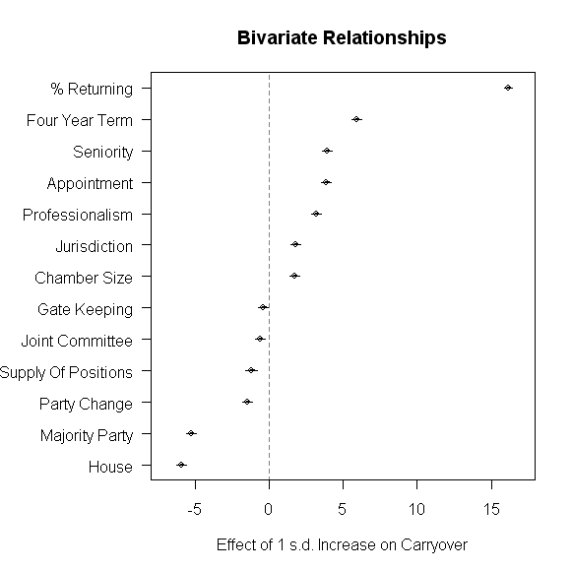

Figure 8: Bivariate Models of Committee Member Retention Rates

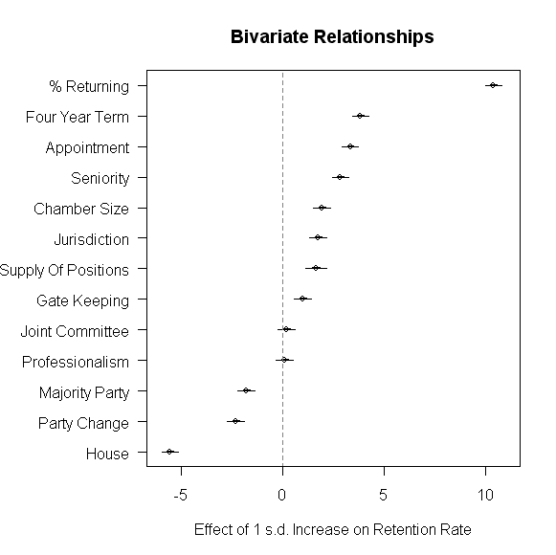

Figure 9: Combined Model of Committee Member Retention Rates

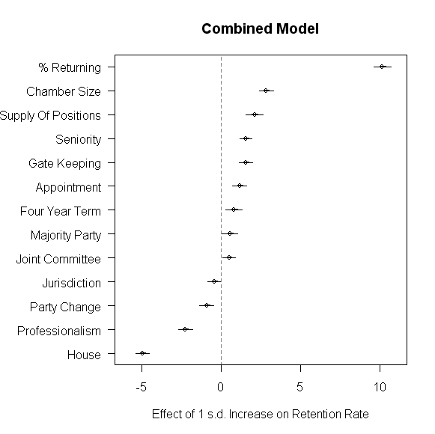

Figure 10: Hierarchical model of Committee Member Retention Rates

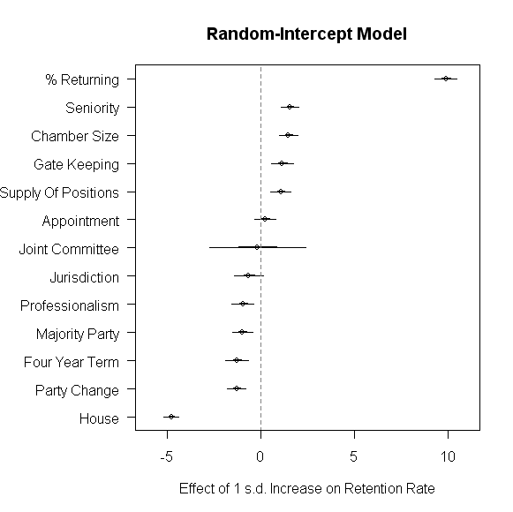
Figure 11: Varying Intercept and Slopes for Model of Retention

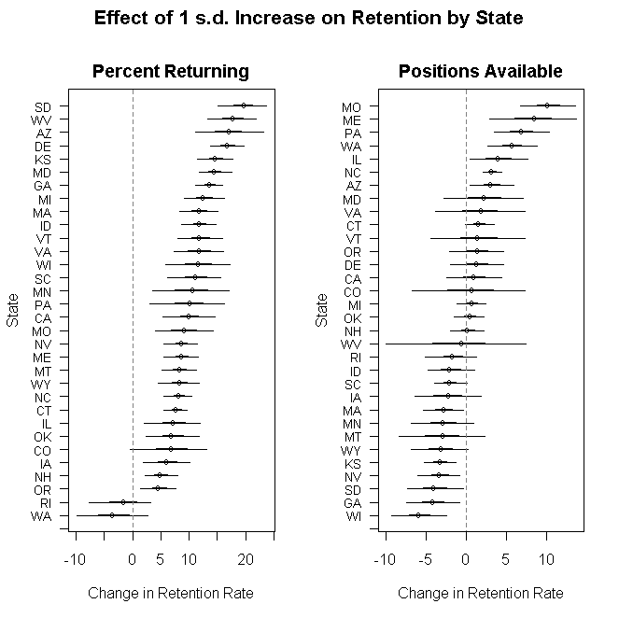

Figure 11 continued: Varying Intercept and Slopes for Model of Retention

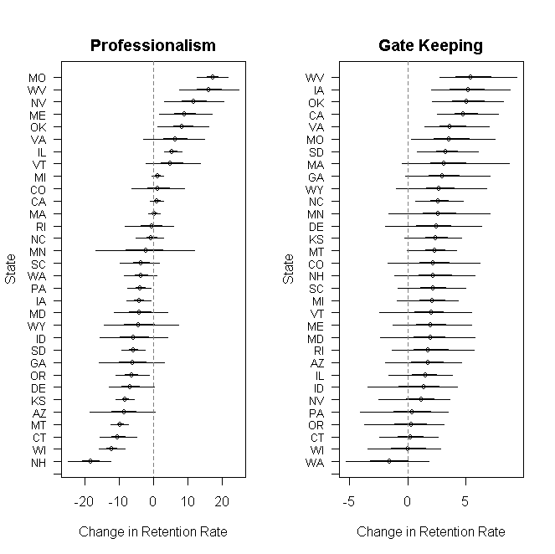

Figure 11 continued: Varying Intercept and Slopes for Model of Retention

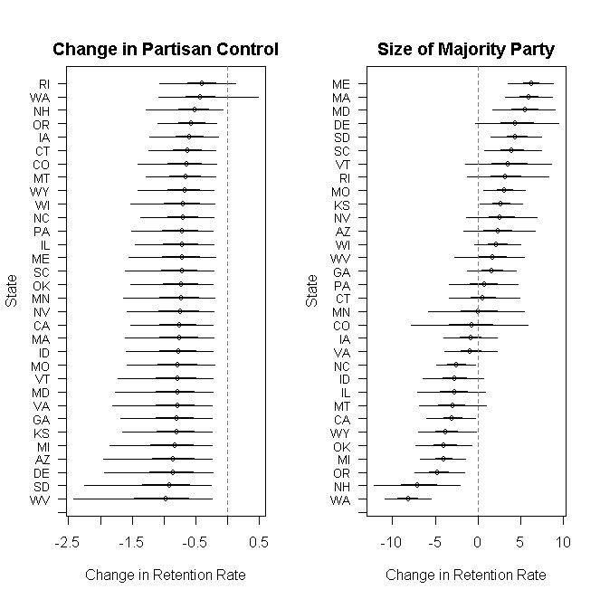

Figure 11 continued: Varying Intercept and Slopes for Model of Retention

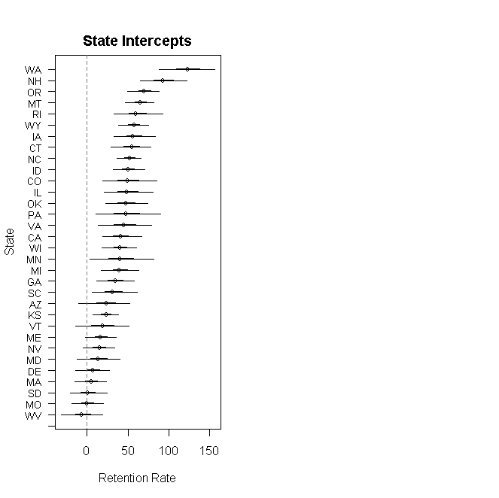

Table 1: Fixed parameter estimates

 |  |  | 95% Confidence Interval
Variable | Coefficient | S.E. | Lower | Upper
Jurisdiction | 2.9 | 1.9 | -0.9 | 6.5
Appoint | -0.1 | 0.6 | -1.2 | 1.0
4 year | -1.1 | 3.9 | -9.5 | 5.6
Size09 | 0.0 | 0.0 | 0.0 | 0.0
House | -9.7 | 0.5 | -10.6 | -8.8
Joint | -4.6 | 5.3 | -14.6 | 3.8

Appendix

Table A1: Estimated Slopes from Bivariate Regressions

 | Percent Reappointed |  | Percent Reappointed of Reelected
Variable | Coef.  (S.E.) | p-value | Coef.  (S.E.) | p-value
Professionalism | 25.306  (1.612) | .000 | .865  (1.990) | .664
% Returning | .661  (.007) | .000 | .425  (.010) | .000
Gate Keeping | -.388  (.238) | .104 | 1.070  (.289) | .000
Jurisdiction | 5.402  (.616) | .000 | 5.217  (.772) | .000
Appointment | 4.674  (.243) | .000 | 3.996  (.297) | .000
Seniority | 37.538  (1.972) | .000 | 27.319  (2.352) | .000
Party Change | -4.453  (.619) | .000 | -6.939  (.760) | .000
Majority Size | -.353  (.013) | .000 | -.120  (.017) | .000
Supply of Pos. | -.068  (.014) | .000 | .096  (.018) | .000
Four year term | 32.244  (1.064) | .000 | 20.754  (1.299) | .000
Joint Comm. | -2.090  (.677) | .002 | .656  (.847) | .439
Size | .031  (.004) | .000 | .034  (.005) | .000
House | -11.818  (.402) | .000 | -11.139  (.500) | .000

Table A2: Combined model results

Variable | Coefficient | S.E. | p-value
Intercept | 35.047 | 2.092 | .000
Professionalism | -17.640 | 2.101 | .000
% Return | .415 | .013 | .000
GateKeeping | 1.679 | .284 | .000
Jurisdiction | -1.269 | .790 | .108
PartyChange | -2.750 | .819 | .001
MajorityParty | .038 | .020 | .062
Appoint | 1.391 | .336 | .000
Seniority | 15.026 | 2.252 | .000
Avail. | .123 | .019 | .000
Four year | 4.390 | 1.663 | .008
Size09 | .050 | .005 | .000
House | -9.898 | .514 | .000
Joint | 1.714 | .826 | .038
N= 14253
R²= .129

BIBLIOGRAPHY

American Society of Legislative Clerks and Secretaries. 1988. Inside the Legislative Process: A Comprehensive Survey of the American Society of Legislative Clerks and Secretaries. Denver, CO: National Conference of State Legislatures.

Battista, James Coleman. 2004. “Re-examining Legislative Committee Representativeness in the States,” State Politics and Policy Quarterly 4: 161-180.

Battista, James Coleman. 2006a. “Jurisdiction, Institutional Structure, and Committee Representativeness,” Political Research Quarterly 59: 47-56.

Battista, James Coleman. 2006b. “Committee Theories and Committee Votes: Internal Committee Behavior in the California Legislature,” State Politics and Policy Quarterly 6: 151-173.

Berkman, Michael B. 2001. “Legislative Professionalism and the Demand for Groups: The Institutional Context of Interest Population Density.” Legislative Studies Quarterly 26:661-79.

Berry, William D., Michael B. Berkman, and Stuart Schneiderman. 2000. “Legislative Professionalism and Incumbent Reelection: The Development of Institutional Boundaries.” American Political Science Review 94:859-74.

Blondel, Jean. 1973. Comparative Legislatures. Englewood Cliffs, NJ: Prentice-Hall.

Clark, Wesley, Jr. and David W. Lippitt. 1978. “Committee Assignment Preferences in a State Legislature: The Case of the New York Assembly.” Paper presented at the 1978 Annual Meeting of the Midwest Political Science Association.

Clucas, Richard A. 2001. “Principal-Agent Theory and the Power of State House Speakers.” Legislative Studies Quarterly 26:319-38.

Cox, Gary W. and Mathew D. McCubbins. 1993. Legislative Leviathan: Party Government in the House. Berkeley, CA: University of California Press.

__________________________________. 2005. Setting the Agenda: Responsible Party Government in the U.S House of Representatives. New York: New York: Cambridge University Press.

DeBats, Donald A. 1990. “An Uncertain Arena: The Georgia House of Representatives, 1808-1861,” The Journal of Southern History 56 (August).

Deering, Christopher J. and Steven S. Smith. 1997. Committees in Congress. Third Edition. Washington, D.C.: CQ Press.
Dodds, H.W. 1918. Procedure in State Legislatures. Philadelphia: The American Academy of Political and Social Science.

Eulau, Heinz and Vera McCluggage. 1985. "Standing Committees in Legislatures," in Handbook of Legislative Research. Cambridge, MA: Harvard University Press.

Fenno, Richard F. 1973. Congressmen in Committees. Boston: Little, Brown, and Company.

Francis, Wayne L. 1982. “Legislative Committee Systems, Optimal Committee Size, and the Costs of Decision Making,” Journal of Politics 44:823-837.

______________. 1989. The Legislative Committee Game: A Comparative Analysis of Fifty States. Columbus, OH: Ohio State University Press.

Francis, Wayne L. and James W. Riddlesperger, 1982. "US State Legislative Committees: Structure, Procedural Efficiency and Party Control," Legislative Studies Quarterly 5 (February): 31-54.

Freeman, Patricia K. and Ronald D. Hedlund. 1993. “The Functions of Committee Change in U.S. State Legislatures.” Political Research Quarterly 46: 911-929.

Froman, Lewis A. 1968. "Organizational Theory and the Explanation of Important Characteristics of Congress." American Political Science Review. 62: 518-526.

Gamm, Gerald and John Huber. 2002. “Legislatures as Political Institutions: Beyond the Contemporary Congress” pp. 313-341 in Political Science: State of the Discipline (New York : W.W. Norton & Company, Inc.)

Gilligan, Thomas W. and Keith Krehbiel. 1990. “Organization of Informative Committees by a Rational Legislature.” American Journal of Political Science 34 (May): 531-564.

Hamm, Keith E. 1986. "The Role of 'Subgovernments' in U.S. State Policy Making: An Exploratory Analysis," Legislative Studies Quarterly (August): 321-351.

Hamm, Keith E. and Ronald D. Hedlund. 1989. “Occupational Interests and State Legislative Committees: Explaining Dominance and Representation.” Paper presented at the 1989 Midwest Political Science Association meeting.

Hamm, Keith E. and Ronald D. Hedlund. 1990. "Accounting for Change in the Number of Committee Positions," Legislative Studies Quarterly (May): 201-226.

________________________________. 1992. “The Evolution of Specialization in State Legislative Committee Systems: A Multi-Level Explanation,” Paper presented at the 1992 Midwest Political Science Association meeting.

________________________________. 1994. "Committees in State Legislatures," in The Encyclopedia of the American Legislative System, Joel J. Silbey et. al., (ed.). New York: Charles Scribner and Sons.

________________________________. 1995. “The Development of Committee Specialization in State Legislatures.” Paper presented at the annual meeting of the American Political Science Association.

________________________________. 2004. The Evolution of Committee Specialization in U.S. State Legislatures: The Impact of Professiolnalization,” Paper prepared for presentation at the IPSA Research Committee of Legislative Specialist Conference on Sub-State/Sub-National Legislatures: Representation, Policy-Making and Governance, October 21-23,2004, Quebec City, Quebec, Canada.

________________________________. 2006. “Legislative Professionalization and Committee Systems: Institutional Versus Individual-Level Impact.” A research paper prepared for the 20th International Political Science Association World Congress, Fukuoka, Japan. July 9-13, 2006.

Harlow, Ralph Volney. 1917. The History of Legislative Methods in the Period before 1825. New Haven: Yale University Press.

Harris, Freed R. and Paul L. Hain. 1983. American Legislative Processes: Congress and the States. Glenview, IL: Scott, Foresman and Company.

Hedlund, Ronald D. and Keith E. Hamm. 1994. “The Evolution and Role of Committee Specialization in the Legislative Process: Developing and Testing a Cross-System Model,” a paper presented at the 1994 Meeting of the International Political Science Association (Berlin, Germany), organized by the Research Committee of Legislative Specialists.

________________________________. 1996. “Political Parties as Vehicles for Organizing U.S. State Legislative Committees.” Legislative Studies Quarterly 21:383-408.

Hedlund, Ronald D., Kevin Coombs, Nancy Martorano and Keith E. Hamm. “Appointing Legislative Committees: The Effects of Party, Institution and Committee Jurisdiction.” Paper prepared for delivery at the 2007 Annual Meeting of the Northeastern Political Science Association.

Jameson, J. Franklin. 1894. "The Origin of the Standing-Committee System in American Legislative Bodies," American Political Science Review. 246-267.

Jenkins, Jeffrey A. 1998. “Property Rights and the Emergence of Standing Committee Dominance in the Nineteenth-Century House: Property Rights and the Emergence of Standing Committee Dominance in the Nineteenth-Century House. Legislative Studies Quarterly
23: 493-519.

Jewell, Malcolm. 1969. The State Legislature: Politics and Practice (2nd edition). New York: Random House.

Jewell, Malcolm E. and Samuel C. Patterson. 1986. The Legislative Process: Congress and the States. Fourth Edition. New York: Random House.

Jewett, Aubrey and Roger Handberg. 1999. “GOP Rules Changes in the Florida House.” Comparative State Politics 20 (August): 27-48.

Katz, Jonathon N., and Brian R. Sala. 1996. “Careerism, Committee Assignments, and the Electoral Connection.” American Political Science Review 90:21-33.

Keefe, William J. and Morris S. Ogul. 1985. The American Legislative Process: Congress and the States. Sixth edition. Englewood Cliffs: Prentice-Hall.

King, James D. 2000. “Changes in Professionalism in U.S. State Legislatures.” Legislative Studies Quarterly 25:327-43.

Krehbiel, Keith. 1991. Information and Legislative Organization. Ann Arbor: University of Michigan Press.

Kurtz, Karl T., Gary Moncrief, Richard G. Niemi and Lynda W. Powell. 2006. “Full-Time, Part-Time, and Real-Time: Explaining State Legislators’ Perceptions of Time on the Job,” State Politics and Policy Quarterly 6: 322-338.

Lees, John D. and Malcolm Shaw (eds). 1979. Committees in Legislatures. Durham, NC: Duke University Press.

Loftus, Tom. 1994. The Art of Legislative Politics. Washington, D.C.: Congressional Quarterly Press.

Luce, Robert. 1922. Legislative Procedure: Parliamentary Practices and the Course of Business in the Framing of Statutes. Boston: Houghton Mifflin Company.

Martorano, Nancy. 2006. “Balancing Power: Committee System Autonomy and Legislative Organization.” Legislative Studies Quarterly. Forthcoming.

Martorano, Nancy, Keith E. Hamm and Ronald D. Hedlund. 2000. Examining Committee Structures, Procedures, and Powers in U.S. State Legislatures: A Comparative Chamber Analysis. A paper delivered at the 2000 Annual Meeting of the Midwestern Political Science Association, Chicago, Illinois, April 27-30, 2000.

Mattson, Ingvar, and Kaare Strøm. 1995. “Parliamentary Committees.” In Herbert Doring, ed., Parliaments and Majority Rule in Western Europe. Frankfurt, New York: Campus Verlag/St. Martin’s Press.

Mezey, Michael. 1979. Comparative Legislatures. (Durham, N.C: Duke University Press).

Morris, Allen. 1982. "Florida Legislative Committees: Their Growth Since 1822." Florida Historical Quarterly. LXI (October): 125-147.

Muir, William K., Jr. 1982. Legislature: California School for Politics. Chicago: University of Chicago Press.

Olson, David M. and Michael L. Mezey, (eds). 1991. Legislatures in the Policy Process: The Dilemmas of Economic Policy. Cambridge: Cambridge University Press.

Overby, Marvin and Thomas A. Kazee. 2000. “Outlying Committees in State Legislatures: An Examination of the Prevalence of Committee Outliers in State Legislatures,” Journal of Politics 62: 701-728.

Overby, L. Marvin, Thomas A. Kazee and David W. Prince. 2004. “Committee Outliers in State Legislatures,” Legislative Studies Quarterly 29: 81-108.

Polsby, Nelson W. 1968. "The Institutionalization of the U. S. House of Representatives." American Political Science Review 62(1): 144 - 168.

______________. 1975. Legislatures. Governmental Institutions and Processes. F. I. Greenstein and N. W. Polsby, (eds). Reading, MA., Addison-Wesley: 257 - 319.

Porter, Mason A., Peter J. Mucha, M. E. J. Newman and Casey M. Warmbrand. 2005. “A Network Analysis of Committees in the U. S. House of Representatives.” Proceedings of the National Academy of Sciences of the United States of America. 102: 7057 – 7063.

Price, H. Douglas. 1975. Congress and the Evolution of Legislative "Professionalism". Congress in Change: Evolution and Reform. N. J. Ornstein, (ed). New York, Praeger: 2 - 23.

Prince, David and L. Marvin Overby. 2005. “Legislative Organization Theory and Committee Preference Outliers in State Senates,” State Politics and Policy Quarterly 5: 68-87.

Ray, Bruce A. and Steven S. Smith. 1984. "Committee Size in the US Congress," Legislative Studies Quarterly 9: 679-695.

Reinsch, Paul S. 1907. American Legislatures and Legislative Methods. New York: The Company.

Rosenthal, Alan. 1973. "Legislative Committee Systems: An Explanatory Analysis," Western Political Quarterly 26: 252-262.

_____________. 1974. Legislative Performance in the States. New York: Harper and Row Publishers.

_____________. 1981. Legislative Life: People, Processes and Performances in the States. New York: Harper and Row Publishers.

_____________ 1996. "State Legislative Development: Observations from Three Perspectives." Legislative Studies Quarterly 21(2): 169-198.

_____________1998. The Decline of Representative Democracy: Process, Participation, and Power in State Legislatures. Washington, DC: CQ Press.

Shaw, Malcolm. 1979. "Conclusion," in Committees in Legislatures. Edited by John D. Shaw and Malcolm Lees. Durham, NC: Duke University Press.

Shepsle, Kenneth A. 1978. The Giant Jigsaw Puzzle: Democratic Committee Assignments in the Modern House. Chicago: University of Chicago Press.

______________. 1979. "Institutional Arrangements and Equilibrium in Multidimensional Voting Models." American Journal of Political Science 23(1): 27 - 59.

Shepsle, Kenneth A. and Barry R. Weingast. 1981. "Structure Induced Equilibrium and Legislative Choice." Public Choice 37: 503-19.

___________________________________. 1987. “The Institutional Foundations of Committee Power,” American Political Science Review 81:85-104.

Smith, Steven S. and Christopher J. Deering. 1984. Committees in Congress. Washington, D.C.: Congressional Quarterly Press.

Squire, Peverill. 1988a. “Career Opportunities and Membership Stability in Legislatures.” Legislative Studies Quarterly 13: 65-82.

____________. 1988b. “Member Career Opportunities and the Internal Organization of Legislatures.” Journal of Politics 50: 726-744.

____________. 1992a. “Legislative Professionalization and Membership Diversity in State Legislatures.” Legislative Studies Quarterly 17:69-79.

____________. 1992b. “The Theory of Legislative Institutionalism and the California Assembly.” Journal of Politics 54: 1026-1054.

____________. 1993. “Professionalization and Public Opinion of State Legislatures.” Journal of Politics 55:479-91.

____________. 1998. “Membership Turnover and the Efficient Processing of Legislation.” Legislative Studies Quarterly 23:23-32.

____________. 2006a. “Historical Evolution of Legislatures in the United States.” Annual Review of Political Science: 2006.

____________. 2006b “Professionalization of Legislatures in the United States over the 20th Century." A research paper prepared for the 20th International Political Science Association World Congress, Fukuoka, Japan. July 9-13, 2006.

Squire, Peverill and Keith E. Hamm. 2005. “101 Chambers: Congress, State Legislatures, and the Future of Legislative Studies Columbus OH: Ohio State Univ. Press.

Squire, Peverill, Keith E. Hamm, Ronald D. Hedlund, and Gary Moncrief. 2005. “Electoral Reforms, Membership Stability, and the Existence of Committee Property Rights in American State Legislatures.” British Journal of Political Science.

Stewart, Charles III. 2001. Analyzing Congress. New York; W. W. Norton and Company.

Weingast, Barry and William J. Marshall. 1988. "The Industrial Organization of Congress; or Why Legislatures, Like Firms, Are Not Organized as a Market" Journal of Political Economy 96 (February 1988): 132-63.

Winslow, C.I. 1931. State Legislative Committees: A Study in Procedure. Baltimore: The John Hopkins University Press.

ENDNOTES

Battissa (2006b), in his most recent work which is the most comprehensive attempt to look at legislative institutional choice, concludes that “ The U.S. House need not be a sui genreis body, understood only on its own or with the Senate. It can be understood instead as one of many American legislatures, whose internal organizational decisions are shaped by many of the same factors that shape the organizational decisions of its sister chambers” (2006b:25).
Squire et al (2004) show that in terms of similarities, that members of both institutions operated in the same electoral context, facing the same voters in the same elections backed by the same political parties. Standing committee systems existed in both sorts of legislatures and those systems were similarly stable. State legislators had the same stable committee structures in which they could assert committee property rights, as did their counterparts in the US House.
The average number of committees in the upper house has dropped substantially, from a peak of 33 on average in 1939/40 to a low of roughly 17 in 1977/78. In the lower houses, the peak was reached in 1909/10 with there being on average 41 committees and the low of 20 committees per chamber in 1989/90. The decreases appear to be concentrated during the middle of the century, with the bulk of the drop in the 1940s and 1950s preceding the emergence of the state legislative reform movement in the 1960s and 1970s. Both chambers showed slight upticks in committee numbers in the 1990s.
What is at stake for these legislatures has been a movement toward professionalization of the legislatures’ capacity to deliberate, oversee, and legislate. This has meant a shift of emphasis away from the representational values of legislators as amateur citizens embedded in their local communities. It has more and more demanded their frequent attendance at the state capitol, and while decreasing the salience of local preference, it has increased the significance of legislative structure. This has been for some state legislatures followed by a few decades a pathway very much like the road trod by Congress. (Polsby, 1975:297)
Why should professionalization serve as a jumping off point for any comparative study legislative study? Squire and Hamm cite literature that documents the impact of professionalization on the relationship between the representative and represented, the linkage between public opinion and policy, the structure of internal organizational arrangements, the impact on legislative output, and the level of discretion given to bureaucratic agencies (2005: 95-96).
For example, over two-thirds of the legislators in the non-professional states of Arizona, Colorado, Missouri and Oklahoma claim to spend at least 70 percent of a full-time job on legislative work. (Kurtz et al, 2006: 326.)
Squire goes on to suggest how legislatures should be structured to meet other types of career goals. “The organization of a body where members have progressive career goals should allow any member to gain important positions quickly . . . In a legislature where almost all members have discrete ambitions, power is likely to be centralized in the hands of a few. (Squire, 1988: 727). . . . “The organization of a body where members have progressive career goals should allow any member to gain important positions quickly. . . . In a legislature where almost all members have discrete ambitions, power is likely to be centralized in the hands of a few. (Squire, 1988: 727).
One difference between the operation of the U.S. Congress and state legislatures is the degree to which the legislators set the rules under which they operate. While the U.S. Congress has a completely free hand, some state legislative rules are imposed exogenously while those of the U.S. Congress are endogenously generated. Squire and Hamm make this point when discussing the Colorado Legislature: “In contrast, many state legislative rules are exogenous because they are imposed from outside, either by those who wrote the constitution or by voters who passed amendments to the constitution . . . . In 1988, for example, Colorado voters passed the GAVEL (Give a Vote to Every Legislator) amendment. GAVEL required every bill referred to a committee to be brought up for a committee vote, . . . that all bills reported by committee go to the floor,… and prohibited party caucuses from taking binding votes. (Squire and Hamm, 2005: 38 from Rosenthal 1996, 191 and Strayer 2000, 88, 109, 231). Missouri’s constitution, adopted in 1945, actually enshrines a discharge procedure that does not require majority support: “After it has been referred to a committee, one-third of the elected members of the respective houses shall have power to relieve a committee of further consideration of a bill and place it on the calendar for consideration.” (see Squire and Hamm, 2005: 124) We also want to make the argument that institutions, while occasionally undergoing rapid change, are more likely to change slowly due to a host of factors. “Once highly developed, organizational inertia or “stickiness” (Pierson and Skocpol 2002, 700) may exert a strong enough pull on a legislature that it does not organizationally decay, at least very quickly, even in the face of very high turnover rates (Squire and Hamm, 2005: 151). Because of organizational inertia, we might allow for a considerable time lag between changes in membership turnover and its manifestations in changed rules, norms, and operating procedures. As Squire and Hamm note, in their discussion of term limits: “ Indeed, it seems easy to argue that while some American state legislatures with term limits have much higher turnover rates than before the reform was imposed, most of the indices of their development levels have not changed much at all. Leaders are still typically drawn from the more experienced (if now truncated) ranks, and the ways these chambers organize and make decisions are overwhelmingly the same. Committee systems, for example, continue as before, and the same rules and precedents are still observed” (p. 151).
According to Oleszek (2001, 81), “Precedent, public laws, turf battles, and the jurisdictional mandates of the committees are set forth in the rules of the House and Senate determine which committees receive which kinds of bills.”
They also “create[d] policy councils to organize the various committees and to rank all bills in priority order that have cleared committee for floor consideration; limit[ed] members to four bills referred at one time; allow[ed] bills to be carried over to the second year; increase[d] notice requirements; . . . limit[ed] what can be considered in the last days of the session;” (Jewett and Handberg, 1999: 27)
For example, Jameson suggested that in the 18th century committees emerged in legislatures with 50 to 100 members while the same did not happen in the smaller chamber of New York with only 25 members (Jameson, 1894: 266). Morris provides information about the lower house in the Florida Legislature that offers a most unusual explanation. He notes that as counties were created, more legislators were added to the chamber; however, since there was a chamber rule from the mid-1840s to the mid-1920s setting the size of each committee at between five and nine members, the leadership had no option but to increase the number of committees (Morris, 1982: 128). Increased chamber size indirectly affected the increase in the number of committees in Florida, but not in the manner suggested elsewhere.
They found that chamber size was correlated with the number of committees (r=.37) and with the average size of committees (r=.65) (1982: 460. See also Francis, 1989: 137). Interestingly, the relationship between number of committees and average committee size was spurious once chamber size was taken into account.
? Two states, Massachusetts and Rhode Island, had one year legislative sessions early in the 20th century: pre- 1920 for Massachusetts and pre-1910 for Rhode Island. Thus, for three sessions the years are 1906/7 and 1916/17. We do not believe this difference produced any systematic effect on any of the variables under study in this research.
In the combined models, we again used linear regression. While linear regression is widely used in applied research, we technically do not have a normally distributed outcome variable as the measure of constancy is both discrete and bounded. With a large number of potential values, the variable might approximate a continuous variable, and to check the appropriateness of the normal model for our bounded variables, we assessed the predicted values from the model and found that for every data point the fitted values was within the allowable range of the variable, suggesting that the normal linear model is an appropriate model for these data.
To check for multicollinearity we obtained pairwise correlations between the variables and found that most of the correlations were fairly weak. The strongest association was between the size of the chamber and committee jurisdictions which nevertheless had a fairly modest correlation of .382.
We also estimated models that include a dummy variable controlling for the post 1969 period after which, as discussed above, a number of reforms were implemented in state legislatures. We also estimated models that controlled for decade and while there was some quantitative differences between the estimates, the qualitative conclusions do not depend on the choice of model specification.
With one chain and 1000 iterations on a Dell Optiplex GX620, the estimation took 5 days, 19 hours, and 12 minutes to complete.

